WELCOME TO OMICS DATA AUTOMATION

(Mac OS)
Here are some of the things need to be installed in your Laptop

1.Git
2.Docker
3.Slack
4.AWS Cli
5.Azure Cli
6.Pg Admin
7.SQL workbench
8.Visual Code

---------------------------------------------------------------------------------------------------------------

1. STEPS TO INSTALL GIT

* Download the latest

https://sourceforge.net/projects/git-osx-installer/files/

* Open a terminal and verify the installation was successful by typing

git --version

* Configure your Git username and email using the following
commands

git config --global user.name “ ”

git config --global user.email “ “

* Run

----------------------------------------------------------------------------------------------------------------

2. STEPS TO INSTALL DOCKER

* Download the latest version of Docker Desktop from
https://docs.docker.com/desktop/install/mac-install/
* Open the downloaded file and drag the Docker.dmg file to your
Applications folder.
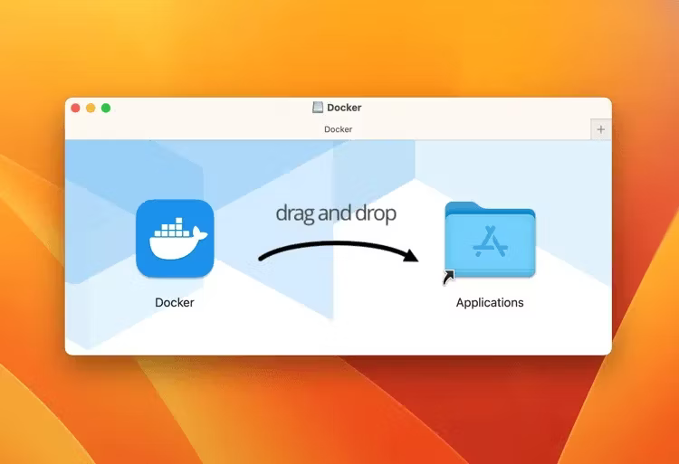

* Open the Docker app from the Applications folder.

* Type in your Mac's password when prompted

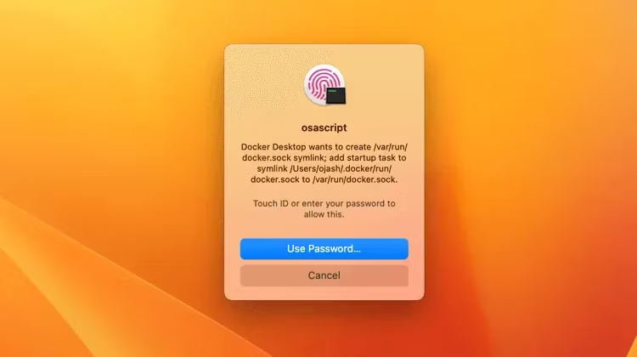

* After this, Docker will configure itself automatically.
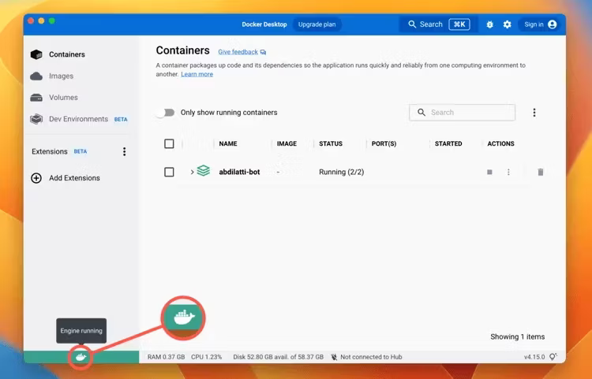

You can confirm your installation by hovering your cursor over the Docker logo on the bottom-left corner of the window, and you should see a pop-up saying, "Engine running."

* After installing Docker Desktop, you should verify that it is working
properly

sudo docker --version

--------------------------------------------------------------------------------------------------

3. STEPS TO INSTALL SLACK

* Paste and run this command

curl -fsSL https://downloads.slack-edge.com/slack-cli/install.sh | bash

----------------------------------------------------------------------------------------------------

4. STEPS TO INSTALL AWS CLI

* Install the AWS CLI package

https://aws.amazon.com/cli/

Once you’ve downloaded the installer, execute it and go through
the steps for installation.

* Open terminal and type

aws --version

* Configure CLI

aws configure

------------------------------------------------------------------------------------------------------

5. STEPS TO INSTALL AZURE CLI

* Before installing Azure, Homebrew package must be installed
open the terminal and type

/bin/bash -c "$(curl -fsSL https://raw.githubusercontent.com/Homebrew/install/master/install.sh)"

* Now install Azure CLI

brew update && brew install azure-cli

* To check the working

az

* To login

az login

----------------------------------------------------------------------------------------------------

6. STEPS TO INSTALL SQL WORKBENCH

* Download mac os from here

https://dev.mysql.com/downloads/workbench/

* Drag & drop MySQL Workbench Logo to application.
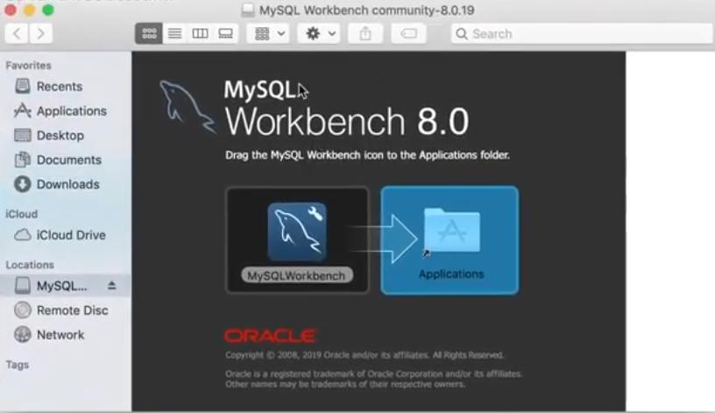

* Create connection

-----------------------------------------------------------------------------------------------------

7. STEPS TO INSTALL VISUAL CODE

* Download Visual Studio Code for macOS.

- Open the browser's download list and locate the downloaded app or archive.
- If archive, extract the archive contents. Use double-click for some browsers or select the 'magnifying glass' icon with Safari.
- Drag Visual Studio Code app to the Applications folder, making it available in the macOS Launchpad.
- Open VS Code from the Applications folder, by double clicking the icon.
- Add VS Code to your Dock by right-clicking on the icon, located in the Dock, to bring up the context menu and choosing Options, Keep in Dock.

* Launching from the command line
You can also run VS Code from the terminal by typing 'code' after
adding it to the path:
- Launch VS Code.
- Open the Command Palette (Cmd+Shift+P) and type 'shell command' to find the Shell Command: Install 'code' command in PATH command.
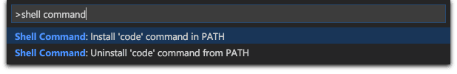
- Restart the terminal for the new $PATH value to take effect. You'll be able to type 'code .' in any folder to start editing files in that folder.
------------------------------------------------------------------------------------------------------

8. STEPS TO INSTALL PG ADMIN

* Install Pg admin

1. Go to the pgAdmin mac download page –

https://www.pgadmin.org/download/pgadmin-4-macos/

2. Select the latest version and on the next page click on the
pgadmin .dmg file to download.
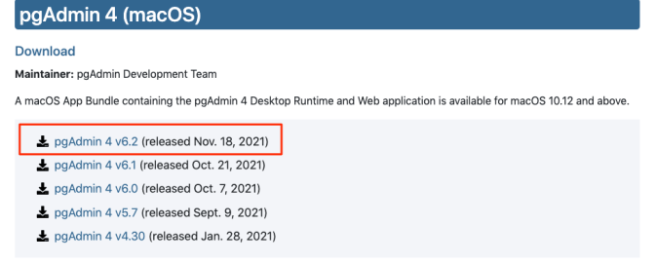

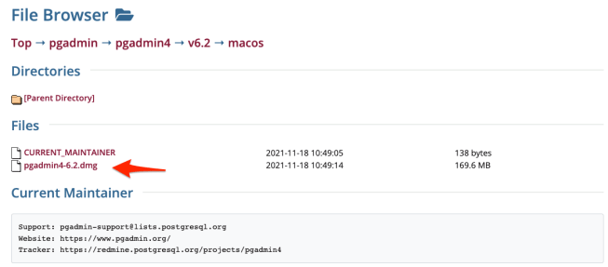

3. Double click the.dmg file and agree the terms. Then drag and drop the pgAdmin 4 app elephant icon to the Application folder.
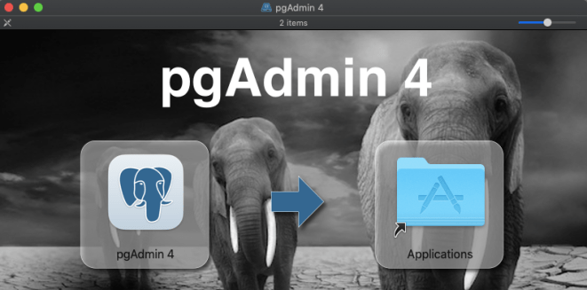

4. Go to the Application folder and double click on the pgAdmin 4 icon to open it. Then click on the servers > PostgreSQL > Databases > postgres.If during the installation process, you have been asked to create a user and password then please do so.
